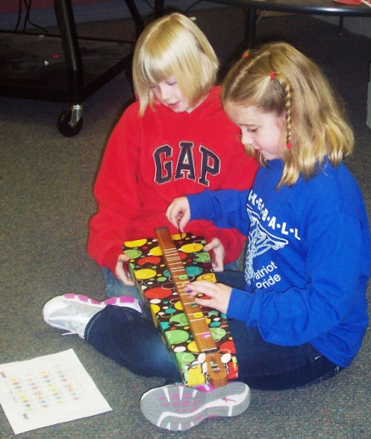 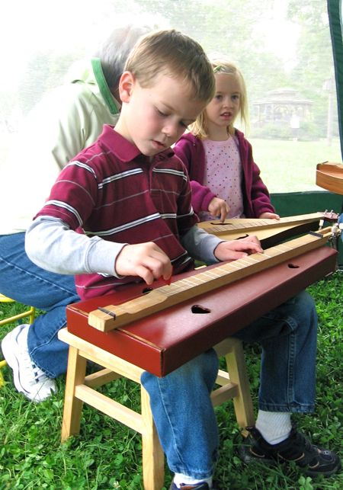

All children love music and what better way to help develop that love than to provide the opportunity to experience hands on lessons by nationally known Instructors.

**Want to learn to play dulcimer or Ukulele?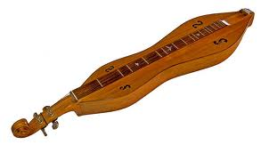**y for **hollywood!**

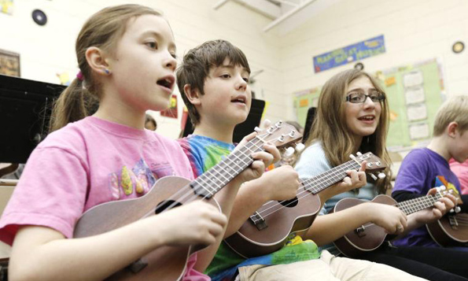

**YOUTH CLASSES for 5th & 6th Grade age group.**

**Southern Strings Dulcimer Festival**

Saturday, February 21st   
William Carey University Campus

$5.00 per 1-hour class

Contact Info: Karen Mims 601-583-6424 or 601-606-1848

Festival Info: [www.mississippidulcimer.com](http://www.mississippidulcimer.com)

Name: _________________________ Parents Name:______________________________

Address:___________________________________ E-mail:_________________________

Phone #: _______________________________ Dulcimer Class _____ Ukulele Class _____

Cost $5.00 per class: Total Cost included: _______________________________________